Anleitung shapefile laden

* Open Gui and connect with gwis as user1
* 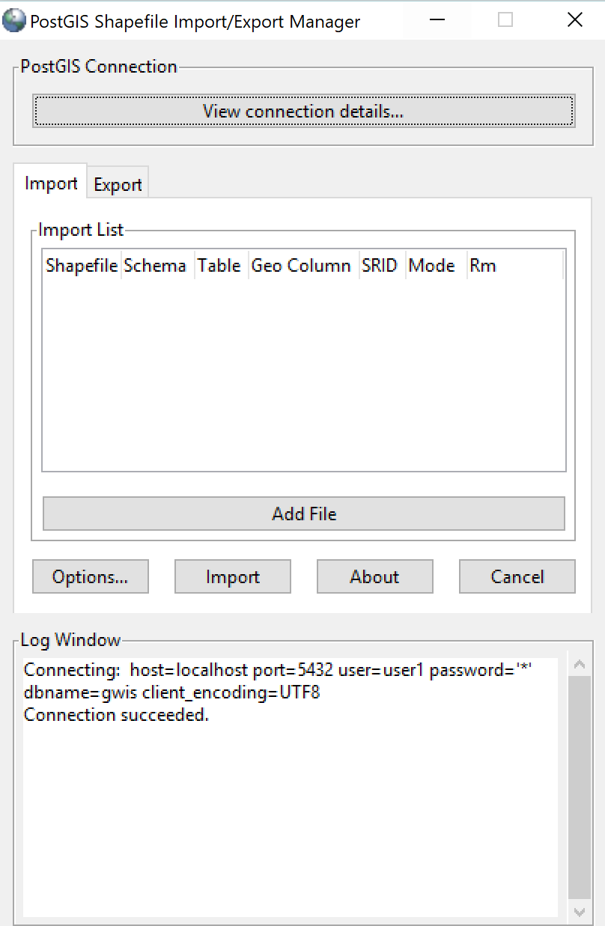
* select «add file» and browse for shapefile
* Enter *4326* as SRID (which corresponds to WGS_1984)
* Enter *nasa_modis_ba* as destination schema
* 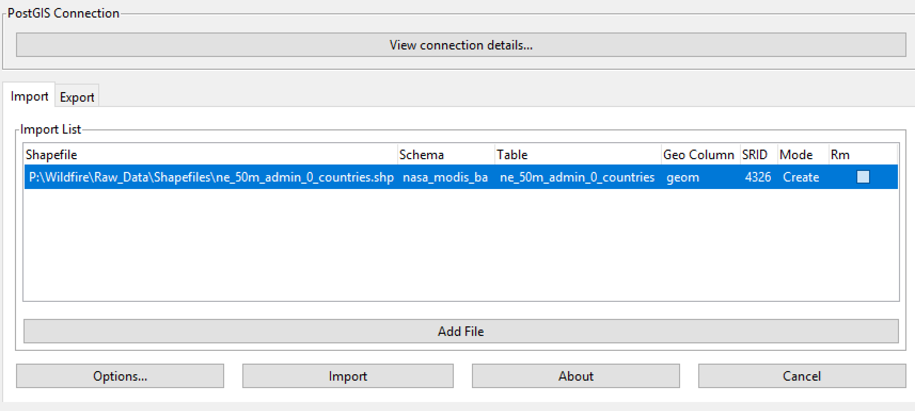
* Click import
* 